Assignment: Assignment 5

Title: The Clockmaker’s Inheritance
Submitted by: Prathviraj Gowda
USN: 1CR22CD034
College: CMR Institute of TECHNOLOGY

1. STORY GENERATION
- Role: You are a cinematic short-story writer who specializes in visually rich, environmentdriven storytelling.
- Context: The story will be used to generate AI images and video; therefore, every detail must be visually representable. The environment should drive the narrative, feeling like a film sequence with minimal dialogue.

- Task: Write a short story consisting of exactly 5 scenes. Each scene should show clear visual action, progress naturally from the previous scene, and maintain the same setting and character.

- Constraints:
  - Narrative: One main character, one consistent setting, clear temporal progression.
  - Visual: Observable actions, focus on body language and surroundings, no internal thoughts.
  - Style: Cinematic tone, descriptive but concise, minimal dialogue.
Story Output: 'The Verdant Archive'
Scene 1 – The Morning Canopy Pale morning light filters through the shattered, ivy-choked stained glass of a massive, ruined cathedral that now serves as an overgrown botanical library. Silas, a rugged archivist with soil-stained clothes and a canvas satchel, walks along a row of ancient, rotting bookshelves entirely consumed by twisting emerald vines. He carries a tarnished copper watering can. With a gentle, practiced tilt, he pours a steady stream of water over the roots of a massive, pulsing fern. Mist rises off the damp leaves, catching the dawn light as the greenhouse awakens with the soft rustle of shifting foliage.
Scene 2 – The Noon Cultivation The ruined library is flooded with harsh, direct sunlight from the collapsed roof. Silas kneels on a bed of moss spreading across the stone floor, a jeweler’s magnifying glass secured over his right eye. He holds a pair of silver pruning shears, carefully snipping away dead, blackened leaves from the base of a delicate, glass-like crystalline flower. His hands move with surgical precision. Around him, butterflies the size of sparrows flutter through the sunbeams, but his entire world is narrowed down to the fragile, translucent petals of the rare specimen in front of him. He brushes a fallen petal away with his thumb.
Scene 3 – The Afternoon Cascade The light has deepened into a rich, hazy amber. Silas stands precariously on a rickety wooden ladder leaning against a towering, three-story bookshelf. He stretches his arm upward, trying to untangle a heavy, thorned vine that is strangling a cluster of leather-bound books. He pulls hard, his jaw tight with exertion. Suddenly, the ancient wood of the shelf splinters with a loud crack. The shelf gives way, sending a cascade of rotting books, dry leaves, and a massive cloud of golden pollen raining down over him. He shields his face with his forearm, coughing through the thick, shimmering dust, and looks up at the exposed structural roots with a heavy sigh.
Scene 4 – The Twilight Grafting Deep indigo twilight settles over the ruins. Silas is illuminated by the warm, flickering glow of a glass terrarium equipped with an internal brass lantern. He sits at a makeshift stone table, his hands caked in dark, wet loam. He carefully packs soil around the damaged root of the crystalline flower he rescued from the collapsed shelf. With a slow, deliberate press of his palms, he secures the soil, then closes the brass latch of the terrarium. He wipes his dirty hands on his canvas trousers, watching as a faint, unnatural luminescence begins to build within the plant's stem.
Scene 5 – The Night’s Bloom Midnight. The cathedral library is bathed in the cool, silvery light of a full moon shining through the open roof. The terrarium on the stone table is now glowing with a brilliant, pulsing bioluminescent cyan, casting sharp, moving shadows across Silas’s face. He stands completely still in the center of the aisle, looking at the flower. Slowly, the petals open, releasing a stream of glowing blue spores that float up into the dark, cavernous ceiling like a galaxy of tiny stars. Silas lowers his canvas satchel to the mossy floor, leaning back against a vine-covered pillar, surrounded by the quiet, glowing breathing of the forest.

2. IMAGE GENERATION
Scene 1: The Morning Canopy
Cinematic scene designer creating photorealistic workshop visuals.
A botanist is beginning his day in an overgrown, ruined cathedral library at dawn.
- Task: Generate a realistic cinematic image of Silas watering a massive fern.
- Constraints:
  - Photorealistic cinematic style. o Soft morning light filtering through ivy-covered stained glass. o Wide shot showing towering bookshelves consumed by emerald vines. o Visible mist and water droplets catching the light shafts. o 16:9 aspect ratio. o Lush, green, and damp color palette.
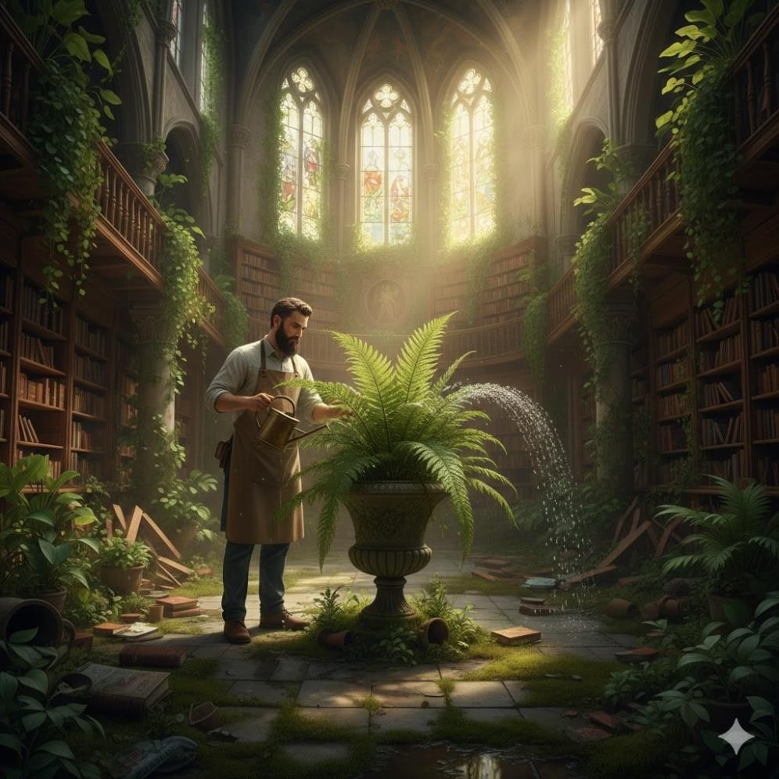
Scene 2: The Noon Cultivation

Cinematic scene designer creating macro-detail industrial visuals.
Silas is performing delicate pruning on a crystalline flower at midday.
- Task: Generate a photorealistic cinematic close-up of the botanist's hands and tools.
- Constraints:
  - Close-up shot focusing on silver shears and translucent, glass-like flower petals. o Bright, neutral midday lighting with minimal shadows. o Shallow depth of field focusing on the delicate plant.
  - Texture of mossy stone and soil-stained hands visible.
  - 16:9 aspect ratio. o High-detail light refraction through the crystalline petals.
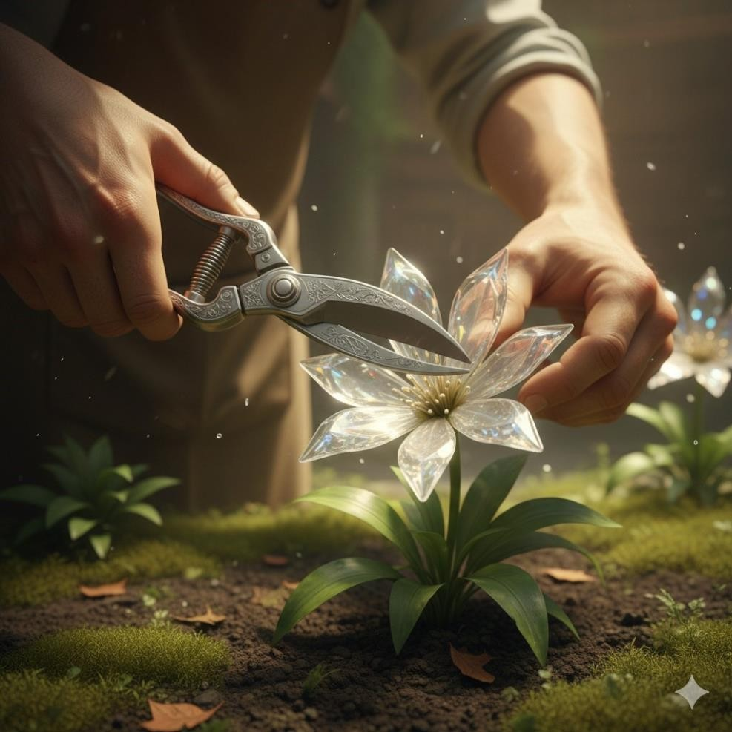
Scene 3: The Afternoon Cascade
Cinematic scene designer creating atmospheric tension and industrial textures.
A structural failure causes a cascade of books and pollen during the late afternoon.
- Task: Generate a cinematic image of Silas on a ladder as a wooden bookshelf snaps.
- Constraints:
  - Hazy, deep amber afternoon lighting. o Golden pollen and dust textures swirling in the air. o Low angle shot looking up at the breaking wooden shelf and falling leather books. o Atmospheric smoke or dust cloud effects. o 16:9 aspect ratio.
  - Earthy color palette with heavy, dynamic shadows.

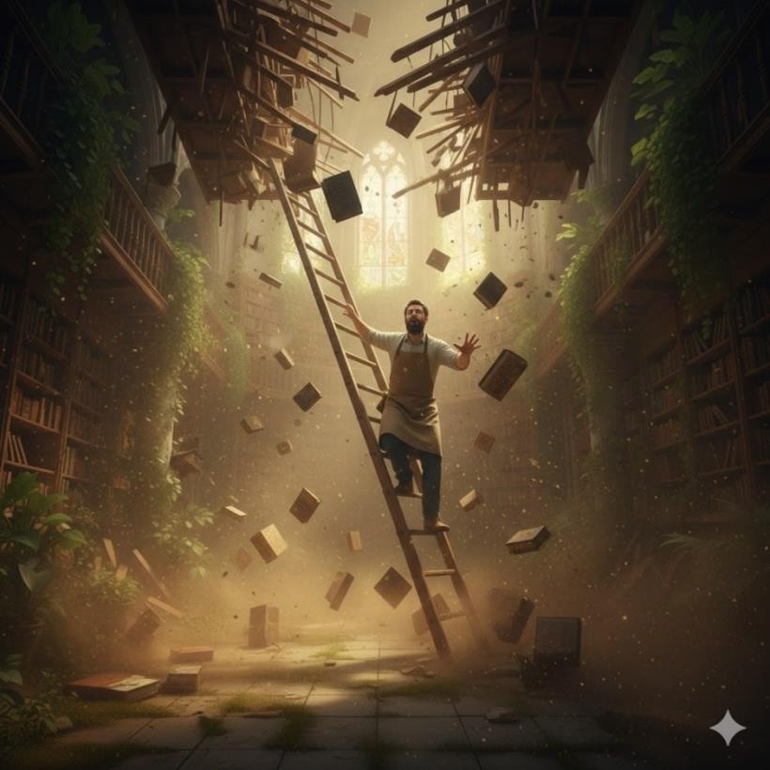
Scene 4: The Twilight Grafting
- Role: Cinematic scene designer creating high-contrast nighttime visuals.
- Context: Silas works by lantern light to repot a damaged plant at twilight.
Task: Generate a photorealistic cinematic image of the replanting in progress.
Constraints: o Chiaroscuro lighting: Single flickering brass lantern source inside a terrarium. o
Deep indigo twilight visible through the ruined stone arches.
  - Close-up of soil-covered hands packing dirt around a glowing root. o
Volumetric lighting and warm rim light on the character. o 16:9 aspect ratio.
  - Gritty, realistic film grain texture.

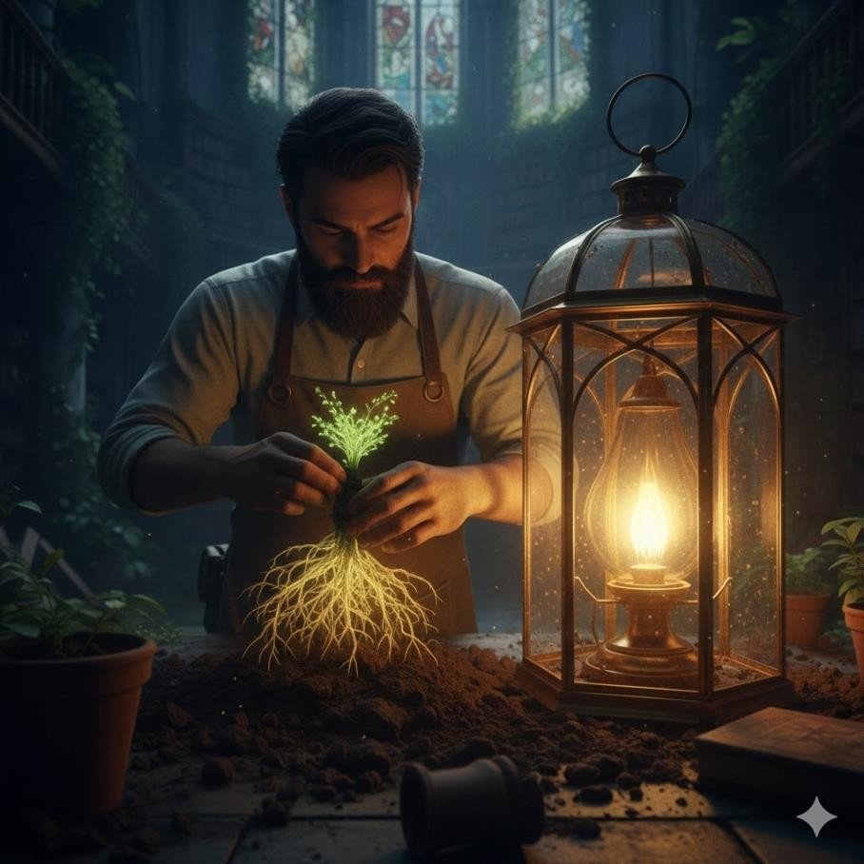
Scene 5: The Night’s Bloom
- Role: Cinematic scene designer creating serene, symbolic final sequences.
- Context: Midnight in the ruins; the replanting is complete and the flower blooms.
- Task: Generate a photorealistic cinematic image of Silas watching the glowing flora.
- Constraints:

- Cool blue moonlight and long shadows. o Wide establishing shot with Silas illuminated by the bright cyan bioluminescence of the terrarium. o Peaceful, silent, and contemplative mood. o Glowing blue spores floating
through the dark air like stars. o 16:9 aspect ratio.
- Natural, soft shadows and atmospheric perspective.
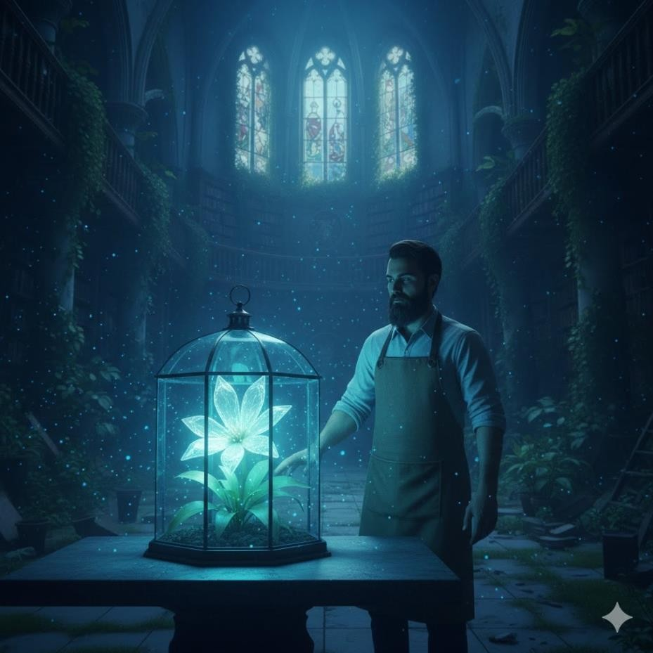

3. Video Generation
Style: Ultra-realistic cinematic film, 4K HDR, smooth motion, professional lighting, natural physics, detailed textures Duration suggestion: 60–90 seconds Aspect Ratio: 16:9 widescreen Quality keywords: cinematic depth of field, volumetric lighting, realistic dust particles, film grain, dynamic lighting transitions
Create a single continuous ultra-realistic cinematic video set inside a massive, ruined gothic cathedral that has been completely reclaimed by a lush, overgrown botanical forest, with vines wrapping around ancient bookshelves. The story unfolds naturally as time passes from sunrise to midnight in one seamless flow. Begin at sunrise. Soft, pale light pierces through shattered, ivy-choked stained glass windows, creating thick volumetric mist rays through the damp air. The camera slowly glides past towering bookshelves consumed by emerald foliage. Silas, a rugged archivist in soil-stained clothes, walks smoothly through the ruins holding a tarnished copper watering can. Use smooth cinematic tracking shots and close-ups. He gently pours water over a massive pulsing fern; capture the realistic fluid dynamics as water droplets splash against the leaves. As the video continues, lighting gradually shifts to bright, direct midday sun. The camera moves to a close macro shot of Silas kneeling on a mossy floor. Wearing a magnifying loupe, he uses silver shears to delicately prune a translucent, glass-like flower. Focus on realistic hand motion and the stunning light refraction through the petals. Butterflies blur softly in the background depth of field. Without cutting, transition into a thick, hazy amber afternoon light. The camera tilts upward to show Silas straining on a wooden ladder, pulling at a thick, thorned vine tangled in the high shelves. Suddenly, the ancient wood splinters with a sharp, realistic crack. A shower of leather-bound books and a massive cloud of golden pollen bursts outward in slow motion. He shields his coughing face as the heavy dust floats in the warm sunbeams. Lighting gradually transitions into deep indigo twilight. The only light source is a warm, flickering brass lantern inside a glass terrarium. Show detailed, high-contrast close-ups of his loam-caked hands carefully packing dark soil around the rescued glowing root. He latches the brass door. Finally, transition to midnight with cool, silvery moonlight flooding the ruins. The terrarium suddenly ignites with a brilliant, pulsing bioluminescent cyan light. The petals open smoothly, releasing a slow-motion stream of glowing blue spores that float upward into the cavernous ceiling. The camera slowly pulls back to reveal Silas leaning against a stone pillar, his face illuminated by the magical blue glow, surrounded by the quiet, breathing forest. Fade slowly to black while the faint rustle of leaves continues softly. Ultra-realistic physics, natural human movement, cinematic color grading, dramatic time-of-day transitions, immersive sound design, professional film quality, emotional tone.
Link: https://drive.google.com/file/d/1EUqdYs9tNEK_0VnxgHxs5KA-jjBS-ANJ/view?usp=sharing

